**Java Web开发**

**实验四**

**作业报告**

|  |  |
| --- | --- |
| 学 院 | 计算机 |
| 所在系 班 级 | 2017软件工程系9班 |
| 学 号 姓 名 | 03170609 祝志豪 |
| 指 导 教 师 | 郭晓燕 |
| 完 成 时 间 | 2019年4月1日 |

# 实验题目

登录页面，提交用户名、密码及身份

改写一：支持中文，确保两种表单提交方式（get、post）都支持中文，另外对程序的空对象情况进行处理。

改写二：比如登录页面除了之前的用户名、密码另外再加上所在专业（计算机、软件工程及网络工程，单选框或下拉列表框皆可），登录成功后根据身份进行跳转，进入对应的页面，页面需显示****专业学号姓名。登录失败转向失败页面，并进行报错！

# 分析与设计

根据题目要求，计划设计几个文件来完成实验，每个文件的名字、作用。如果是类，要求写出类的变量和方法

# 关键源码（部分）

<!DOCTYPE html>

<html>

<head>

<title>Login.html</title>

<meta name=*"keywords"* content=*"keyword1,keyword2,keyword3"*>

<meta name=*"description"* content=*"this is my page"*>

<meta name=*"content-type"* content=*"text/html; charset=GB2312"*>

</head>

<body>

<form method=*"post"* action=*'DoLogin.view'*>

学号：<input type=*'text'* name=*'username'* >

姓名：<input type=*'text'* name=*'studentname'* ><br>

密码：<input type=*'password'* name=*'password'*><br>

专业：<select name=*"domain"*>

<option>软件工程</option>

<option>信息管理</option>

<option>网络工程</option>

<option>计算机科学与工程</option>

</select><br>

<input TYPE=*"submit"* value=*"登录"* name=*"submit"*>

</form>

</body>

</html>

package test4;

import java.io.IOException;

import java.io.PrintWriter;

import javax.servlet.ServletException;

import javax.servlet.annotation.WebServlet;

import javax.servlet.http.HttpServlet;

import javax.servlet.http.HttpServletRequest;

import javax.servlet.http.HttpServletResponse;

@WebServlet("/DoLogin.view")

public class DoLogin extends HttpServlet {

public DoLogin() {

super();

}

public void destroy() {

super.destroy(); // Just puts "destroy" string in log

// Put your code here

}

public void doGet(HttpServletRequest request, HttpServletResponse response) throws ServletException, IOException {

this.doPost(request, response);

}

public void doPost(HttpServletRequest request, HttpServletResponse response) throws ServletException, IOException {

request.setCharacterEncoding("GB2312");

response.setContentType("text/html;charset=UTF-8");

String username = request.getParameter("username");

String domain = request.getParameter("domain");

String studentname = request.getParameter("studentname");

String password = request.getParameter("password");

request.setAttribute("username", username);

if(username.length()==8 && password.length()==6 && !(username=="" && password=="" && studentname==""))

{

request.getRequestDispatcher("success.jsp")

.forward(request, response);

}

else

{

request.getRequestDispatcher("fail.jsp")

.forward(request,response);

}

}

public void init() throws ServletException {

// Put your code here

}

}

<%@ page language=*"java"* import=*"java.util.*"* pageEncoding=*"utf-8"*%>

<%

String path = request.getContextPath();

String basePath = request.getScheme()+"://"+request.getServerName()+":"+request.getServerPort()+path+"/";

%>

<!DOCTYPE HTML PUBLIC "-//W3C//DTD HTML 4.01 Transitional//EN">

<html>

<head>

<base href=*"*<%=basePath%>*"*>

<title>My JSP 'success.jsp' starting page</title>

<meta http-equiv=*"pragma"* content=*"no-cache"*>

<meta http-equiv=*"cache-control"* content=*"no-cache"*>

<meta http-equiv=*"expires"* content=*"0"*>

<meta http-equiv=*"keywords"* content=*"keyword1,keyword2,keyword3"*>

<meta http-equiv=*"description"* content=*"This is my page"*>

<!--

<link rel="stylesheet" type="text/css" href="styles.css">

-->

</head>

<body>

<%

request.setCharacterEncoding("GB2312");

String username=(String)request.getAttribute("username");

String domain=request.getParameter("domain");

String studentname=request.getParameter("studentname");

out.println("<p>登陆成功</p>");

out.println("<p>学号："+username+"</p>");

out.println("<p>姓名："+studentname+"</p>");

out.println("<p>专业："+domain+"</p>");

%>

如果要回到登陆界面请点击超链接

<a href=*"Login.html"*>回到登陆界面</a>

</body>

</html>

<%@ page language=*"java"* import=*"java.util.*"* pageEncoding=*"utf-8"*%>

<%

String path = request.getContextPath();

String basePath = request.getScheme()+"://"+request.getServerName()+":"+request.getServerPort()+path+"/";

%>

<!DOCTYPE HTML PUBLIC "-//W3C//DTD HTML 4.01 Transitional//EN">

<html>

<head>

<base href=*"*<%=basePath%>*"*>

<title>My JSP 'fail.jsp' starting page</title>

<meta http-equiv=*"pragma"* content=*"no-cache"*>

<meta http-equiv=*"cache-control"* content=*"no-cache"*>

<meta http-equiv=*"expires"* content=*"0"*>

<meta http-equiv=*"keywords"* content=*"keyword1,keyword2,keyword3"*>

<meta http-equiv=*"description"* content=*"This is my page"*>

<!--

<link rel="stylesheet" type="text/css" href="styles.css">

-->

</head>

<body>

<%

request.setCharacterEncoding("GB2312");

String username=(String)request.getAttribute("username");

String domain=request.getParameter("domain");

String password = request.getParameter("password");

String studentname=request.getParameter("studentname");

**if**(username==""||studentname==""||password=="")

{

out.println("<p>信息没有填写完毕，请点击超链接重新登陆</p>");

}

**else**{

out.println("<p>"+username+" 用户名或者密码出错，请点击超链接重新登陆</p>");

}

%>

<a href=*"Login.html"*>回到登陆界面</a>

</body>

</html>

# 运行效果图

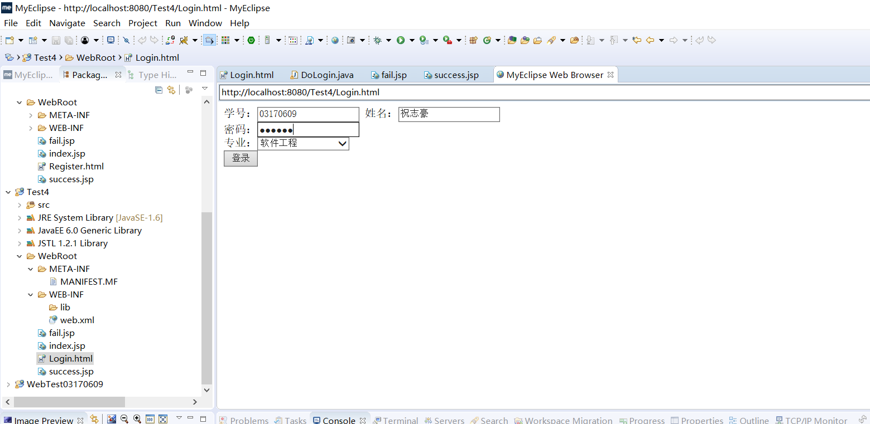

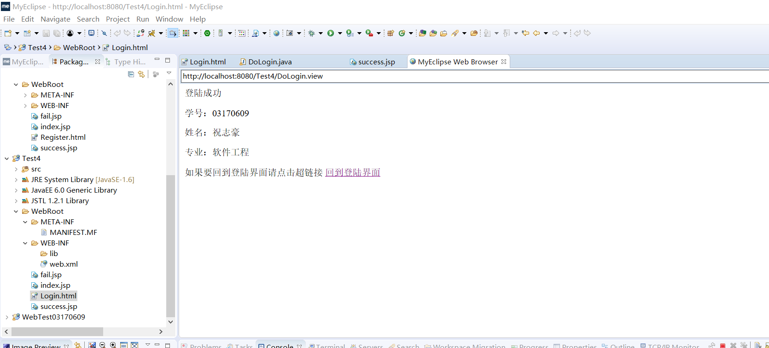

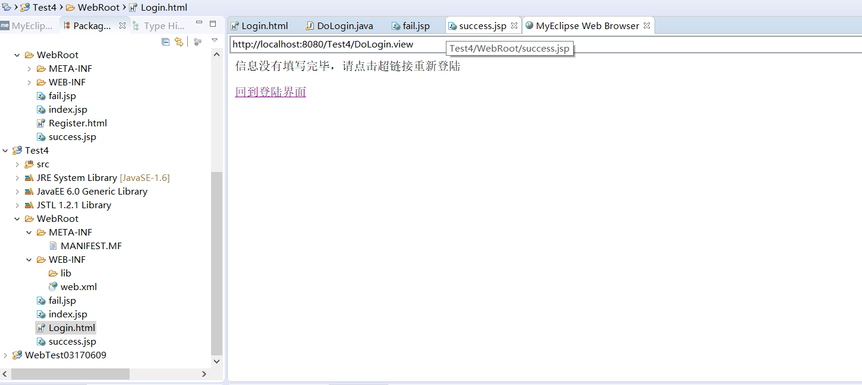

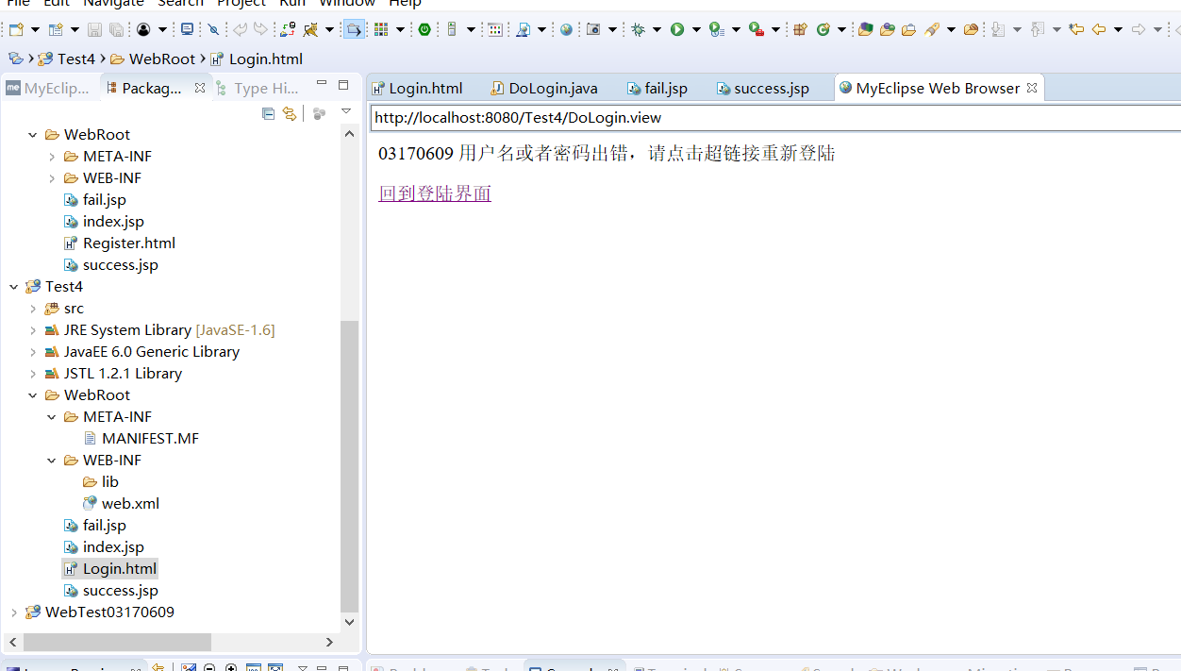

# 收获与问题